Proud to Care North London Portal

User Manual for Employers
INTRODUCTION
- Create an account
Go to https://www.proudtocarenorthlondon.org.uk/login

Click on sign in/register at the top right of the page:

Click ‘create an account’ and fill in the short form.
You will receive one email from the Proud to Care Administrator with your log in details and your password.
Follow the link to verify your account and sign in with your password. You will be immediately prompted to change your password.
2. General Navigation
Once logged in you should see the following screen.
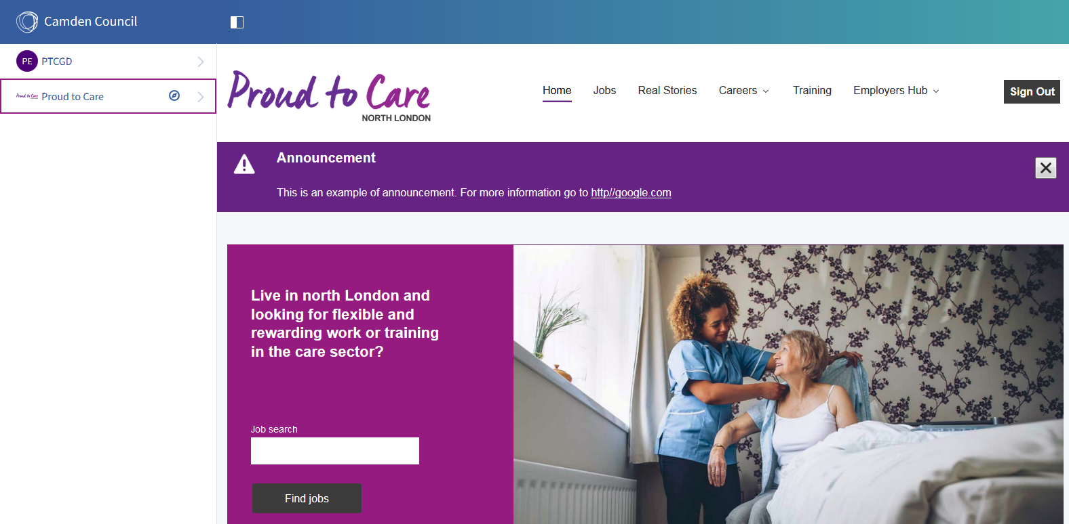
Note: If the menu on the left hand side is not there click on the white rectangle icon in the blue bar. If the Camden council site is displayed then click on the compass icon in the left hand menu and choose ‘Proud to Care’. To Navigate back to the home page click ‘Proud to Care’ > ‘Go to site’.
Once signed in the main areas you will use are:
Employers Hub: in the top right corner, this contains all website content specific for employers, including uploading and managing jobs, viewing training, events and other employer specific content.
The left hand menu bar: under your screen name > my account > my submissions, this provides the back office functions for receiving feedback on your job submissions from Proud to Care.
3. Uploading a new job
Go to the employers hub. Click advertise your vacancies.
Click advertise vacancy.
Complete the form.
The form gives you two options for receiving applications. ‘Proud to Care form’ will provide a short form to applicants, which will be sent the email address you provide. ‘External URL’ will redirect applicants to an external page of your choice from where they can continue their application.
When you have completed the application click save.
The submission will be reviewed by the Proud to Care North London team before the advert goes live. The outcome (whether the job was approved, rejected or any comments from PTC) will be emailed to you and appear in your notifications in the left hand menu bar.

4. View, edit and delete a job
Go to employers hub > advertise your vacancies. All previous submissions are displayed in the list below.
Click on the ellipses (three dots) for the job you want to work on.
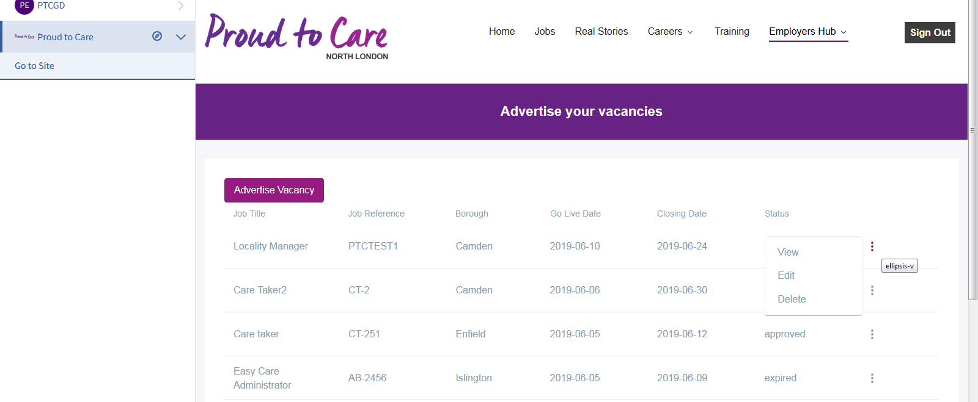

Click the option you want, either view, edit or delete.
5. Advertise a new job using an old JD
You can use an old JD for new jobs to save time. Simply follow the process above for an expired job and click edit. You can then change the dates, and make other appropriate alterations.

