Children placed in Camden
Helpful information for local authorities

If you have placed a child in Camden, you may want to know about the borough and what services and support will be available while they live here.

This factsheet provides information about the borough and contact details for Camden services that you may need to contact in order to ensure looked after children receive the support they need locally and are not disadvantaged by being placed out of borough.

It would be useful if you could pass this factsheet on to your foster carers in Camden or other relevant professionals within your children’s social care service. We would also like to hear from you if you have similar information and contact details about services for children and young people that Camden may place in your borough.

Information about Camden

Camden is a vibrant and ethnically diverse borough situated just north of central London with a population of 212,000. The borough has a mixture of residential, business and retail areas, including Covent Garden, and plenty of green spaces such as Hampstead Heath. It has a variety of well- known attractions including Camden Market, London Zoo and the British Museum. The borough prides itself on being tolerant and inclusive and offering children a safe environment in which to grow up and where learning is encouraged.

Camden provides a wide range of services and facilities for children and young people living in the borough that can help them to achieve their potential.

- Education, early years services, children’s social care services and youth services are all delivered by the Supporting People directorate.

- Libraries and leisure facilities are delivered by the Supporting Communities directorate.

- Children’s social care in Camden is delivered by the Children’s Safeguarding and Social Work (CSSW) division.

Notifications

All notifications of looked after children placed in Camden should be sent to infosharing@camden.gov.uk.cjsm.net. Changes of address and notifications of LAC leaving Camden should also be sent to this address so that we can ensure our records are kept up-to-date.

When notifying Camden of a new placement, change of placement, or placement ending please use Camden’s notification template so that we can ensure we have all the relevant information about the child we need to provide services.

Please ensure that any notifications also highlight particular risks and vulnerabilities to assist Camden’s professional network in responding effectively to any issues that may arise. If you wish to speak to us to get information about the borough before placing a child here, please contact the Children and Families Contact Service on 020 7974 3317.

Safeguarding and child protection

If you need to contact CSSW urgently concerning the welfare of a looked after child, please call Camden’s MASH team on 020 7974 3317 or out of hours the Emergency Duty Team on 020 7974 4444. You can also email the MASH at: LBCMASHadmin@camden.gov.uk

These teams are the first point of contact for all queries or referrals relating to the welfare of a child in Camden and will be notified by local police or other agencies of any child protection concerns or if the young person goes missing or is thought to be involved in child sexual exploitation. The MASH team will ensure that the placing authority is notified of all referrals and concerns and will work in partnership with the placing authority to ensure the child’s safety.

Child care and early education

Camden’s Family Information Service provides a range of information for parents and carers about childcare and early education provision in the borough, including nurseries, child minders and children’s centres.

For more information, contact the Family Information Service on 020 7974 1679 or visit https://www.camden.gov.uk/family-information-early-years

Camden offers eligible 2 year olds, including Looked After Children, free early education and childcare places, for up to 15 hours per week during term time. Applications can be made when the child is 18 months. Further information on the eligibility criteria and how to apply visit https://www.camden.gov.uk/free-early-education-childcare

All children aged 3-4 years, in the borough, are entitled to 15 hours per week of free early education, starting the term after their 3rd birthday. Looked after children can also access an additional 15 hours per week of free early education and childcare provision.

For information on Camden’s children’s centres visit www.camden.gov.uk/camdensurestart or call Freephone 0800 389 5789

Play services

Camden funds several after school clubs and holiday play schemes for children aged four to 13 that are run by local community and voluntary groups. For more information, visit
After-school clubs and holiday playschemes - Camden Council

School admissions

Looked after children are awarded priority admission to Camden’s maintained schools and academies, assuming there is a vacancy at the preferred school. If you need to contact the school admissions team to discuss an application for a school place, please call 020 7974 1625 or visit email via admissions@camden.gov.uk or visit https://www.camden.gov.uk/school-admissions-general

Details of Camden schools, including term dates, can be found at:
https://www.camden.gov.uk/education

Camden’s virtual school

All looked after children aged 3-19 who are living in Camden are registered with and supported by Camden’s virtual school, including children placed in Camden by other local authorities.

Support around education, employment and training for care leavers up to the age of 25 should be provided by the placing authority although ~the Virtual School can provide advice and guidance to placing authorities.

Support is offered by the virtual school head teacher, the deputy virtual head (for post 16 provision) and key stage consultants who work closely with children, their social workers, carers and schools to develop the Personal Education Plan, monitor children’s progress and devise individual packages of support to enable the child to make the most of their education. The virtual school will liaise with placing authorities in relation to schools admissions, exclusions and general educational progress.

To contact the virtual school, call 020 7974 2359 or visit Virtual School for Looked After and Previously Looked After Children - Camden Council

Special educational needs and disability (SEND)

All Camden schools and Pupil Referral units provide a comprehensive range of support for looked after children and young people with SEND. Every school has a SENDCO with responsibility for ensuring looked after children with SEND are included in the whole curriculum and in school life so that they can achieve the best possible educational outcomes.

Looked after children with an Education Health and Care plan (EHCP) will receive a planned programme of support specific to their needs. The home authority remains responsible for funding and in some cases sourcing any special educational provision as specified in a child’s EHC Plan.

Camden’s SEN team must be informed of the move at least 15 days before the move in order to adhere to statutory requirements but where that is not possible, notice must be given on the day of the move. The home SEN team should transfer the pupil’s file to the Camden SEN team so that the team can arrange a temporary placement at an appropriate school prior to the EHC Plan being reviewed.

Schools will provide support and guidance on the child’s social and personal development and overall well-being through, for example, the work of pastoral care staff and mentors.

Particular attention is given to supporting transitions when looked after children are moving on to the next phase of their education or training. This will include careers advice and sometimes support from specialist Connexions advisers.

The first point of contact for the carer of a pupil with an EHCP should be the school’s SENDCO but more information is available at: Special educational needs - Camden Council
Youth services

Camden’s Integrated Youth Support Services provides a wide range of services and interventions, including programmes of positive activities and accredited learning, for young people aged 13-19 and up to 25 years old for those with special educational needs.

The service aims to support young people around issues such as education, housing, careers, relationships and health. For more information, call 020 7974 7253 or visit https://www.camden.gov.uk/web/camden-rise

Camden Careers and Connexions service

Camden Careers and Connexions service offers careers guidance, as well as advice and support on education, work and training to young people aged 13 to 19, or up to 25 for young people with special educational needs and disabilities (SEND). For more information, call 020 7974 7252.

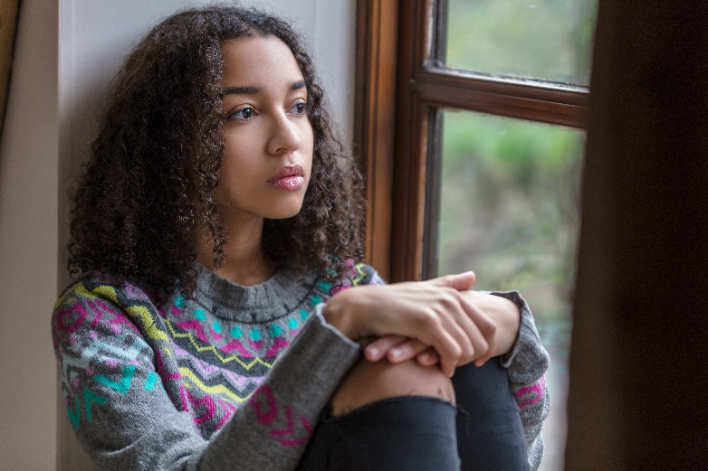
Youth justice

Camden’s Youth Justice Service can offer a statutory youth justice service to young people in Camden who become involved with the police and/or criminal justice system.

Where a young person who is subject to court bail or a community sentence is placed in Camden, the service will agree a “caretaking” arrangement with the home local authority under the National Protocol for Case Responsibility in order to monitor the young person’s compliance and support them to address offending behaviour.

For more information call 020 7974 6181 or visit Youth Offending Service - Camden Rise - Camden Council

Health Services

All children and young people living in Camden have access to universal services provided by Central & North West London NHS Trust, North Central London Integrated Care Board and GPs in Camden. The main hospitals are the Royal Free Hospital and University College London Hospital.

To contact Central & North West London NHS Trust call 0800 988 2149

To contact North Central London Integrated Care Board call 020 3688 1700

Camden’s Designated LAC Nurses are based at the Crowndale Health Centre. To contact them call 020 3317 2403:

Mental health

Camden’s Child and Adolescent Mental Health Service (CAMHS) will offer a service to looked after children and unaccompanied asylum seeking children with mental health difficulties who are placed in Camden by other local authorities. However, Camden CAMHS will liaise with the CAMHS in the placing authority area if that service wishes to remain involved with the child.

Under the responsible commissioner rules Camden CAMHS will negotiate with the placing authority for payment for any CAMHS provided to the child. Referral to the CAMHS should be made directly to the joint intake team at the Tavistock Clinic; the clinic can be contacted on 020 8938 2241 to discuss the referral or contacted at the following email address. CYAF-Intake (TAVISTOCK AND PORTMAN NHS FOUNDATION TRUST) tpn-tr.cyaf-intake@nhs.net.

Drug and alcohol services

All young people living in pathways accommodation in Camden or attending school or college in Camden can access the FWD young people’s drug and alcohol services.

The service works with children and young people aged between 8 and 25 years of age who are affected by their own or their parents substance misuse, and can be contacted on 0207 974 3663 or visit: https://www.camden.gov.uk/web/camden-rise/fwd

Sexual health services

Camden has a range of easily accessible sexual health clinics providing one to one advice and support on sex and relationships and contraceptives. The services are free and open to all young people living in Camden. Services are provided by:

- Brook Euston: 92-94 Chalton Street, NW1 1HJ
0207 387 8700

- The Brandon Centre: 26 Prince of Wales Road, NW5 3LG
0207 267 4792

Participation and advocacy

Children placed in Camden by other boroughs are welcome to join our participation events and are also invited to the Children in Care Council meetings. For details, contact the Participation Officer on 020 7974 1850.

All looked after children living in Camden can access our young people’s participation website, Backchat, which can be found at backchatonline.org.uk, and if they are aged 13-19 years they can also take part in our Youth Council; more information can be found at Home - Camden Rise - Camden Council

Unfortunately, Camden is unable to provide local advocacy services for children who have been placed in the borough by other local authorities.

Leisure facilities

Children placed in Camden are welcome to join any of Camden’s 10 libraries. For details call 020 7974 4444 or visit Libraries, local studies and archives - Camden Council

For information on sports and other activities in Camden visit Sports and leisure - Camden Council

